These are the styles we will stock during our massive sale. We will have 10 different styles ranging from dress pump to ranch boots there will be a style for everyone.

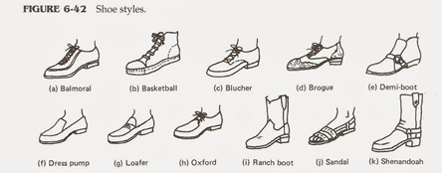

**The reason behind our massive record sale**

Hot shoe shuffle has now been in business for 10 years and we are looking to expand. We have now got the trust from the public knowing you all love out brands and styles so we have chosen to give you more opportunities where ever you may be to visit our stores. At this current moment we have 1 shop in Victoria and we are looking to have a new shop in Queensland – Australian.

**New news coming from hot shoe shuffle head quarters**

We know have a website that can be accessed all over the world!!! And with a promise that there will be shipping to your door in 1 business week or you get the product for free! We will have constant updates on sales and any new information about the company on that website. There is a free membership sign up which will offer special prices and sales but (only if you’re a member)

www.hotshoeshuffle.com

Why Hot Shoe Shuffle

Together as a group on the board we sat together to try and think of a name that will really stand out in the shoe business And that’s when we thought of the name” Hot Shoe Shuffle” . We thought our prices will be red hot and you will be shuffling out the door so the name fits in very well with your feelings. Our brand logo was designed and built around our name “Hot shoe shuffle”

Membership

Our membership is free of cost and gives you rewards online and in stores after a certain amount of points have be collected. To get a membership for “Hot Shoe Shuffle” you can sign up online at any time you like or in store during opening hours. Enjoy your rewards!!